SW Beamforming on OneAPI(xPU)

Getting Started Guide

May 2022

Legal Notices and Disclaimers

Intel technologies may require enabled hardware, software or service activation.
You may not use or facilitate the use of this document in connection with any infringement or other legal analysis concerning Intel products described herein. You agree to grant Intel a non-exclusive, royalty-free license to any patent claim thereafter drafted which includes subject matter disclosed herein.
No license (express or implied, by estoppel or otherwise) to any intellectual property rights is granted by this document.
The products described may contain design defects or errors known as errata which may cause the product to deviate from published specifications. Current characterized errata are available on request.
Intel disclaims all express and implied warranties, including without limitation, the implied warranties of merchantability, fitness for a particular purpose, and non-infringement, as well as any warranty arising from course of performance, course of dealing, or usage in trade.
© Intel Corporation. Intel, the Intel logo, and other Intel marks are trademarks of Intel Corporation or its subsidiaries. Other names and brands may be claimed as the property of others.

Contents
1.0 Introduction 5
1.1 How to use this document 5
1.2 Terminology 6
2.0 Host System Setup 7
2.1 Host Development System 7
2.2 Install Basic Packages 7
2.3 Install Intel oneAPI Toolkits 8
3.0 SW Beamforming Setup 8
3.1 Get SW Beamforming for OneAPI(xPU) Source Code 8
3.2 Initialize OneAPI env 8
3.3 GPU lib code 9
3.3.1 Build 9
3.3.2 Run the program 9
3.3.3 See the result and performance 10

Revision History

Date | Revision | Description
May 2022 | 0.1 | First draft

Introduction
The purpose of this document is to guide users in using SW Beamforing on OneAPI for xPU project. This project contains 1 ultrasound software beamforming samples, which process ultrasound raw data into images human readable. The project use Intel OneAPI to do computation acceleration with Intel integrated GPU. The functions are developed based on Supra.
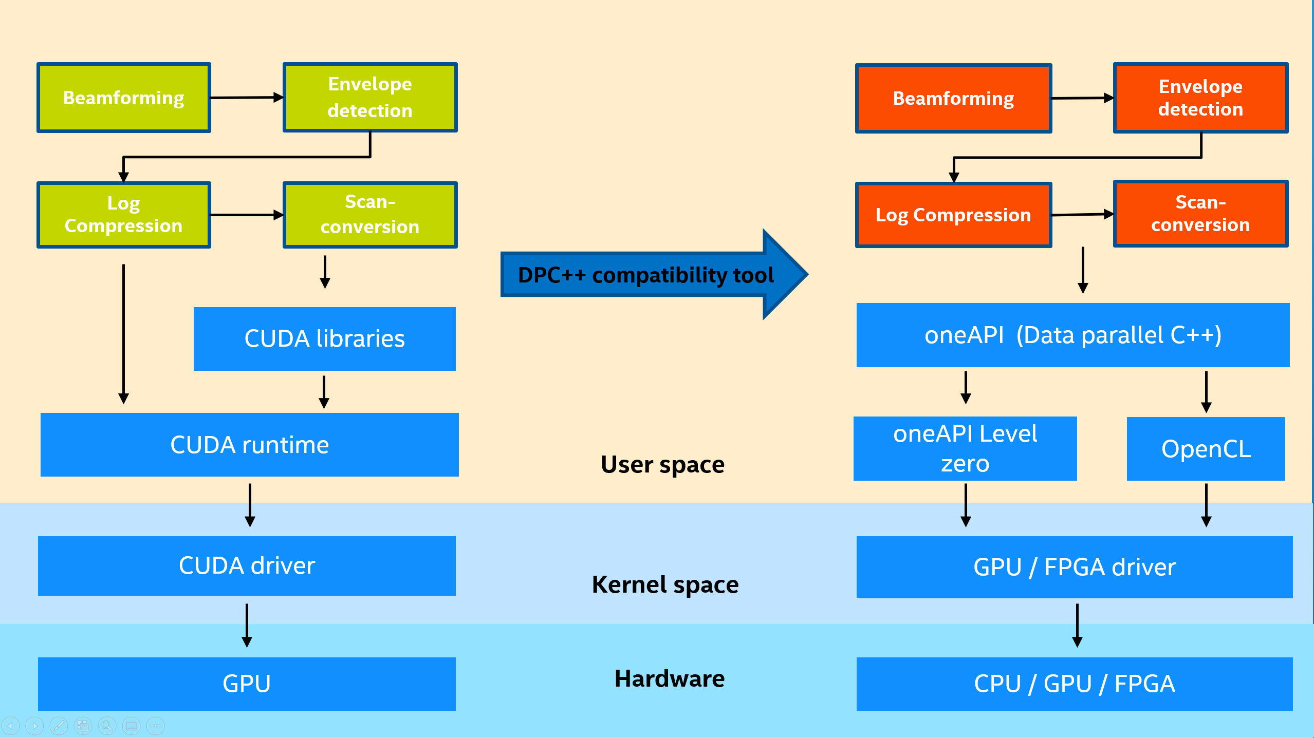
Using oneAPI toolkit -- Intel® DPC++ Compatibility Tool to implement the migration from CUDA to standard DPC++ has been released. For more details, please refer to: https://github.com/intel/supra-on-oneapi. The purpose of this project is for extracting and rewriting the kernel code for easily utilization and running on Intel xPU devices.

How to use this document
If you would like to setup SW Beamforming application to make it run on an Intel device, please follow Chapter2. Host System Setup, and Chapter3. SW Beamforming Setup.

Terminology
Table 1. Terminology
Term | Description
oneAPI | oneAPI is a cross-industry, open, standards-based unified programming model that delivers a common developer experience across accelerator architectures—for faster application performance, more productivity, and greater innovation. Please refer to https://www.oneapi.com/.  Intel® oneAPI products will deliver the tools needed to deploy applications and solutions across the architectures. Please refer to https://software.intel.com/content/www/us/en/develop/tools/oneapi.html
SUPRA | An open-source pipeline for fully software defined ultrasound processing for real-time applications. Covering everything from beamforming to output of B-Mode images, SUPRA can help reproducibility of results and allows modifications to the image acquisition.
DPC++ | At the core of the oneAPI specification is DPC++, an open, cross-architecture language built upon the ISO C++ and Khronos SYCL standards.
Intel® DPC++ Compatibility Tool | The Intel® DPC++ Compatibility Tool assists in migrating your existing CUDA code to Data Parallel C++ (DPC++) code. Refer to https://software.intel.com/content/www/us/en/develop/tools/oneapi/components/dpc-compatibility-tool.html
§

Host System Setup
In this section, we’ll explain how to set up your development system and necessary software packages.

Host Development System
The preferred (and tested) development host platform is PC with Windows 11 24H2. The PC could have an integrated Graphics Processing Unit.
This project has been tested on Intel® Core™ Ultra 7 Processor 255H CPU with Intel® Arc™ 140T GPU, please refer to https://www.intel.com/content/www/us/en/products/sku/241751/intel-core-ultra-7-processor-255h-24m-cache-up-to-5-10-ghz/specifications.html.
This project has been tested on Intel® Core™ Ultra 5 Processor 125H CPU with Intel® Arc™ graphics, please refer to https://www.intel.com/content/www/us/en/products/sku/236848/intel-core-ultra-5-processor-125h-18m-cache-up-to-4-50-ghz/specifications.html.

Install Basic Packages
Please install visual studio 2022, this is the reference link:
https://visualstudio.microsoft.com/downloads/
Must Installed:
Workloads: Desktop development with C++
Individual components: MSVC v143 – VS 2022 C++ x64/x86 build tools(Latest), C++ CMake tools for Windows, Windows 11 SDK
Optional installed:
Individual components: C++ Clang Compiler for Windows, MSBuild support for LLVM(clang-cl) toolset

Install Intel oneAPI Toolkits
Please refer to Intel(R) oneAPI installation guide: https://software.intel.com/content/www/us/en/develop/articles/installation-guide-for-intel-oneapi-toolkits.html.

SW Beamforming Setup

Get SW Beamforming for OneAPI(xPU) Source Code
Download the source code from Github.

$ git clone https://github.com/intel/SW_Beamforming_on_OneAPI(xPU)

Initialize OneAPI env
After source code download, and patches applied, let’s start compile it. Initialize one API environment:
Press Win key and enter oneAPI, select the “Intel oneAPI command prompt for intel 64 for Visual Studio 2022” and click “Run as administrator. After click Yes, you can see the follow window:

:: initializing oneAPI environment...
Initializing Visual Studio command-line environment...
Visual Studio version 17.14.19 environment configured.
"C:\Program Files\Microsoft Visual Studio\<version>\"
Visual Studio command-line environment initialized for: 'x64'
: advisor -- latest
: compiler -- latest
: dal -- latest
: dev-utilities -- latest
: dnnl -- latest
: dpcpp-ct -- latest
: dpl -- latest
: ipp -- latest
: ippcp -- latest
: mkl -- latest
: ocloc -- latest
: tbb -- latest
: umf -- latest
: vtune -- latest
:: oneAPI environment initialized ::

GPU lib code

Build
Enter the project folder.

$ cd SW_Beamforming_on_OneAPI(xPU)/gpu
Create a directory build at the gpu directory:

$ mkdir build
$ cd build
If you want to test the GPU performance for easy testing, and use ZMC(Zero Memory Copy) feature is selected to use or not (which is set to use ZMC by default), run cmake using the command:

$ cmake -G "NMake Makefiles" -DUSE_ZMC=ON/OFF -DCMAKE_BUILD_TYPE=Release ..
Then run make using the command:

$ nmake
Note: ZMC(Zero Memory Copy) can be only used with Intel integrated GPU.

Run the program
Download data to build directory.

$ mkdir data
$ cd data
$ wget https://f000.backblazeb2.com/file/supra-sample-data/mockData_linearProbe.zip
$ unzip mockData_linearProbe.zip
$ cd ..
If just test the GPU performance for easy testing, run the command:

$ easy_app.exe data/linearProbe_IPCAI_128-2.mock data/linearProbe_IPCAI_128-2_0.raw

See the result and performance
Comsuming time of each kernel's calculation could be seen in the terminal.
Visual *.png results are stored in /res directory. You could also specify the directory to store result by running the command:

$ easy_app.exe data/linearProbe_IPCAI_128-2.mock data/linearProbe_IPCAI_128-2_0.raw <directory to store results>

